**PGE 392K – Reservoir Simulation**

**Project 1**

**Oct 30 (5 pm)**

**HOMEWORK SUBMISSION GUIDELINES**

**An automated workflow is utilized in the grading process. Please read carefully to meet the submission guidelines**

Upload all items below to canvas in a single **.zip file** (not .rar or other extensions) named (Your Last Name, Your First Name). The content of the main (zipped) folder should be as follows:

* 1. Homework Powerpoint Template.
  2. a PDF file of additional items to submit such as written notes and whatever you wanted to add to the ppt file but couldn't.
  3. a PDF file of scanned signed cover sheet
  4. A folder that contains all your other files

1. Notes on filling the PowerPoint solution template:
   * 1. **Do not add or remove slides.**
     2. Use a reasonable number of significant figures
     3. Make sure you use proper limits for your plots (including 2D plots) with proper labels for axis, color bars, legend and title.
     4. Wherever you are asked to submit screenshots, use your judgment to decide which parts of your code/ written notes are the most important and take screenshots of that.
2. Notes on the content of the homework files folder:
   1. You do not need to compress this folder separately. Just compress the main folder
   2. Main items: (PPT file and PDFs of coversheet and additional notes should be in the main folder, not in subfolders.
   3. The codes should be clearly labelled (ex Q1A, Q2B.. etc) and they should run. Make sure that you have everything needed to run the codes. You should test it before you send it.
3. **Upload a PDF of this cover sheet after signing the waiver below:**

**I verify that I have I completed this homework on my own accord. I have not used homework solutions from a previous semester of 392K. If I worked in a group, I contributed my share and I am confident I could re-do the homework entirely on my own. By signing my name, I verify that these statements are true and if it is found that they are not true, it may result in a severe penalty (F in the course and reported to Dean of Judicial Affairs)**

Signature ___________________

Printed Name__________________ EID____________

**Model Development** Write a program to solve for the time and spatially-varying pressures for the flow of a slightly compressible fluid in a two dimensional reservoir with varying depth, that is, flow in the reservoir is affected by gravity effects in both the x and y directions. The minimum specifications for this program are:

* Two-dimensional areal geometry
* Arbitrary number of wells and well locations. The wells module should be dynamic enough to enable seamless conversion from a producer to an injector depending on the well schedule. In addition, the wells can switch from a rate to pressure constraints or vice versa; they can also be horizontal wells
* Spatially varying and anisotropic permeability tensor (diagonal)
* Spatially varying depth, porosity, permeability, and thickness
* Pressure dependent flowing phase viscosity and formation volume factor
* Include gravity effects
* Flexible boundary conditions (Neumann or Dirichlet)

**Problem 1** Test your code against the example problem

* L= 1200 ft, W = 600 ft, h= 200 ft
* Kx = [1800 2000 1600 2000 2500 1200 1000 2000 2200] mD
* Ky = 2*kx; kz= 0.1*kx;
* Porosity = [0.26 0.20 0.23 .22 .24 .18 .25 .20 .22]
* Ct = 5.0E-6 psi-1
* Visc = 1 cp; FVF = 1.0 RB/STB
* Density = 62.4 lbm/ft3
* $∆$ x = [200 600 400];
* $∆$ y = [100 300 200];
* $∆$ t = 0.01 days
* Implicit method
* BCs = Dirichlet (P – 1200 on right; No flow on other 3 boundaries)
* Wells (all rw=0.5 ft; skin = -0.75)
  + Constant rate producer (10000 scf/day) at x = 600 ft; y = 300 ft)
  + Constant BHP (1500 psi) at x = 1000 ft; y = 500 ft
* depth = [1883.2 2275.6 2300.6 1883.2 2275.6 2300.6 1883.2 2275.6 2300.6]
* Pinit = 1000 psi at 2309.5 ft

Make the following plots and calculations:

1. Pressure at 0.01 days and at steady state [Slide 2].
2. Filled contour plot of pressure at two interesting times (early and middle)[Slide 3]
3. A Plot of well pressure versus time for the constant rate well [Slide 4, left]
4. Plot of well rate versus time for the constant BHP well [Slide 4, right]

Problem 2 Application: You will be applying your code to the Nechelik reservoir. The reservoir has a length of 6000 ft in the x-direction and 7500 ft in the y-direction. For this exercise the reservoir will be divided into 80 x 75 grids. The reservoir depth, porosity and permeability (x-direction) field are shown in the figures below and in the attached text files.

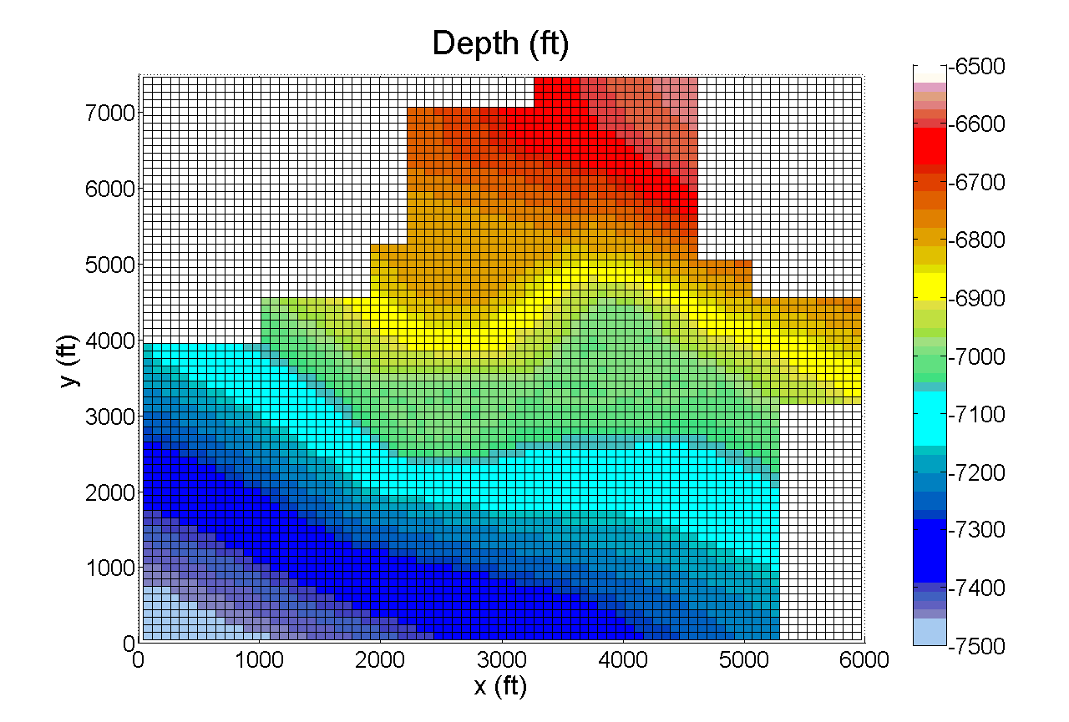

Figure 3: Reservoir depth

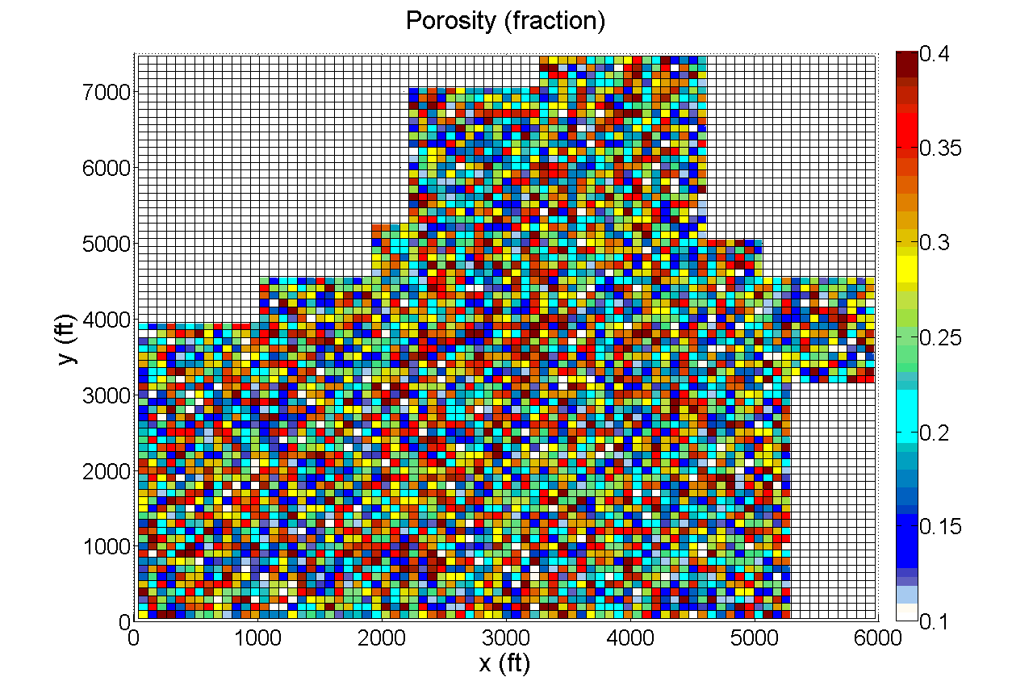

Figure 4: Reservoir porosity

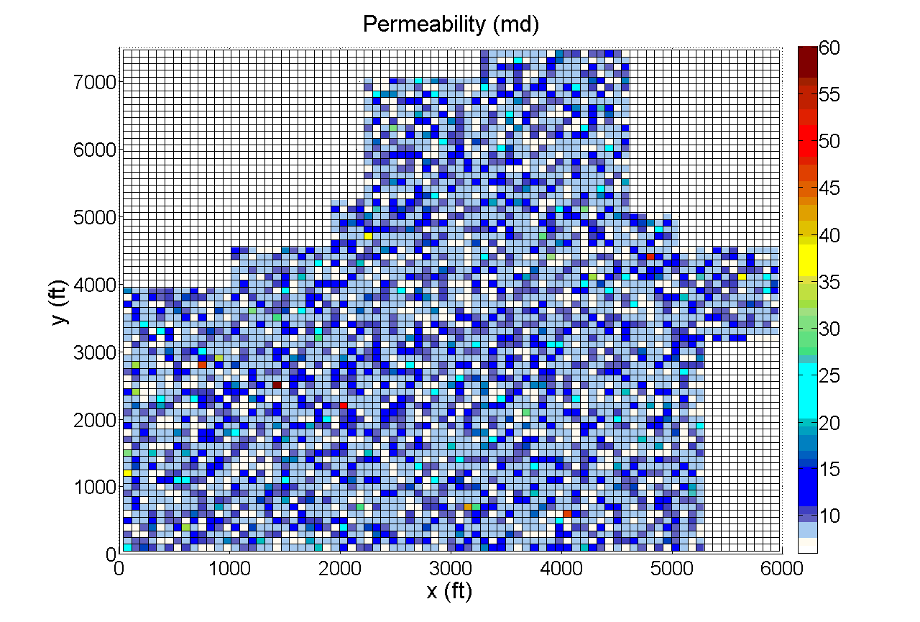

Figure 5: Reservoir permeability

The reservoir thickness is constant (50 ft). Run your model with a time-step of one day. Take the bottom left corner of the graph as the origin. The permeability in the x-direction is presented in the text file titled PJ1-Permeability.txt, the ratio of y-direction permeability to x-direction permeability is 0.15. The z-direction permeability is equal to the x-direction permeability. Fluid properties for the fluids in this reservoir are given in Table 1 below:

Table 1: Fluid Properties

|  |  |
| --- | --- |
| Properties | Water |
| Formation Volume Factor (B) | 1.012298811 |
| Reference Pressure for B [psi] | 4500 |
| Compressibility (c) [psi-1] | 2.87 × 10-6 |
| B(P) |  |
| Density (ρ) [lbm/ft3] | 62.4 |
| Viscosity (μ) [cp] | .383 |
| Compressibility of Formation (cf) [psi-1] | 1x10-6 psi-1 |

Initialize the pressure of the reservoir assuming that the reservoir is 100% saturated with brine and that pressure is 4500 psia at 7495 feet. You may need to iterate since density is pressure dependent (similar to question 2a of Homework 1)

The wells in this reservoir are summarized in Table 2 below; the x and y coordinate of the wells are located in column 4 and 5 respectively:

Table 1 : Well summary

|  |  |  |  |  |  |  |
| --- | --- | --- | --- | --- | --- | --- |
| Well Number | Well Type | Well Condition | x (ft) | y (ft) | Rate (STB/d) | Pressure (psi) |
| 1 | Vertical | Constant rate | 3637.5 | 5550 | 120 | 502.505 |
| 2 | Vertical | Constant rate | 3787.5 | 3550 | 90 | 502.505 |
| 3 | Horizontal | Constant pressure | 2475~2700 | 4350 |  | 502.505 |
| 4 | Horizontal | Constant pressure | 2175~2400 | 2650 |  | 502.505 |
| 5 | Vertical | Constant rate | 1087.5 | 1050 | 500 | 502.505 |
| 6 | Vertical | Constant rate | 412.5 | 3050 | 500 | 502.505 |

Radius is 0.25 ft and skin is 0 for all wells.

Wells 1 and 2 start as constant rate producing wells (check column 6 of table 2 for their respective rates). If their BHP<502.505 psi, they are switched to a constant pressure well (P=502.505 psi). Wells 3 through 6 start as constant pressure producing wells (check column 7 of table 2 for their respective rates).

After 500 days well 1 and 2 are switched to constant pressure wells with bottom-hole flowing pressure summarized in column 7 of table 2. Well 5 and 6 are converted into a constant rate injection well after 500 days with an injection rate of 500 STB/d.

Both horizontal wells are in the x-direction and 225 feet long (3 blocks total in length). You may weigh the horizontal well rates between blocks by total productivity index. If 1st x-coordinate lies on the boundary between 2 blocks, assign first perforation to the block on the right side, and if the 2nd x-coordinate lies on the boundary between blocks, assign last perforation to block on the left side

Important notes about wells:

* BHP producers: when rate is calculated as negative to keep BHP constant, shut the well in until block pressure is high enough to start producing again (block pressure > BHP)
* Rate producers: when BHP is calculated as negative to keep rate constant, change BHP to zero and recalculate rate

1. Make a plot of the well rates for all 6 wells as functions of time (all on the same plot). [Slide 5 left]
2. Make a plot of the bottom hole pressure for all 6 wells (all on same plot). [Slide 5 right]
3. Use your program to generate a contour map of the pressure distribution at initial (0 days), early (300 days), intermediate (600 days) and late times (1000 days). [Slides 6 and 7]
4. Complete the table slides 8 and 9

Note: a grading rubric is provided in the powerpoint template. You will also probably be asked to meet with Dr. Balhoff for a short (<15 minute meeting) to review your results/powerpoint slides for grading.